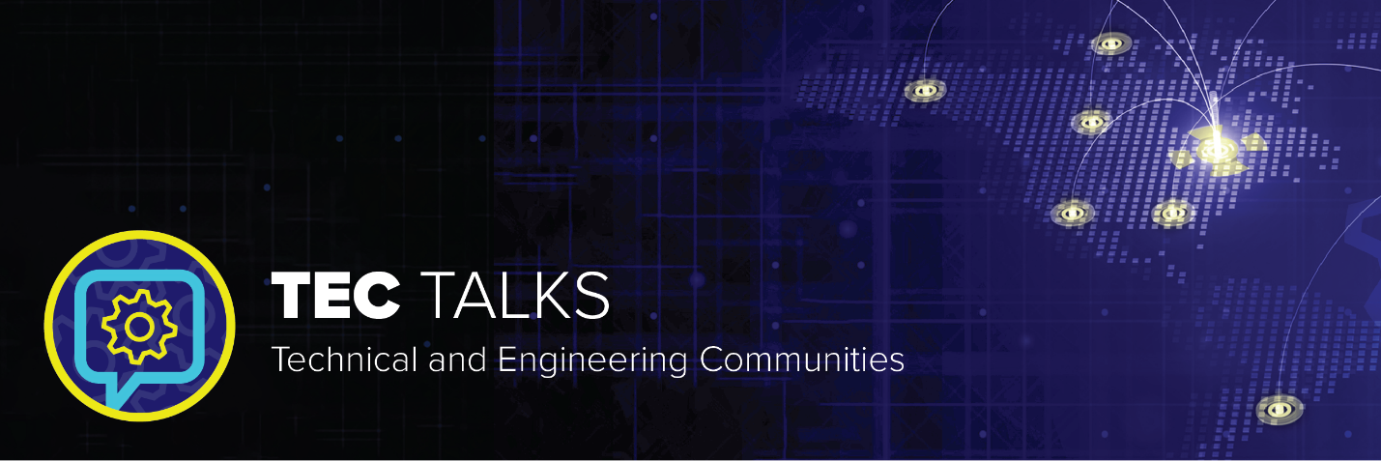

TEC Talks is a monthly webinar series that focuses on timely topics represented by the varied disciplines of ASME’s Technical Divisions.

TEC Talks Presentation Proposal
If you would like to submit a presentation to be featured in an upcoming TEC Talk webinar, please complete the information below and return it to ASMETEC@asme.org. All proposals will be reviewed by members of ASME’s office of strategy and innovation and if accepted, we will contact you with a proposed date and time for the webinar. All webinars are 60 minutes in length.
Sponsoring Division:

Primary contact name and email:

Presentation Title:
The presentation should provide topical information on relevant issues to the target audience

Speaker(s):
Note speaker’s full name, professional title and work affiliation

Presentation Description:
The description should:
- Provide specifics on technical aspects of what will be presented
- Indicate who the target audience is and provide information on what the attendee will learn
- Address what problem you are attempting to solve and details of how the webinar will aim to solve it

